
AI COE & Solution Envisioning
By Contoso
<Contact Button> <Pricing Optional>

AI Transformation Offer: AI COE & Solution Envisioning
Overview
AI CoE & Solution Envisioning is a structured engagement designed to help organizations define their AI vision, establish governance, and identify high-value AI use cases aligned to business outcomes.
As the starting phase of the AI Transformation Offer, this engagement focuses on creating the strategic and organizational foundation required for responsible and scalable AI adoption. It helps organizations move from fragmented AI ideation and isolated experimentation to a prioritized, governed pipeline of AI initiatives that can be executed with confidence.
Through executive alignment, business envisioning, and structured use-case prioritization, AI CoE & Solution Envisioning establishes an AI Center of Excellence (CoE), clarifies decision rights, embeds Responsible AI principles, and produces a clear roadmap that feeds directly into AI Foundation Architecture and Generative AI Factory execution.
This offer is designed for organizations that are investing in AI but lack alignment, governance, and clarity on where to start or how to scale responsibly.
Key Benefits
- Establish a clear AI vision and value framework aligned to enterprise business priorities
- Define an AI Center of Excellence (CoE) operating model with governance, roles, and decision rights
- Identify and prioritize high-impact AI and Generative AI use cases using a structured scorecard approach
- Align business scenarios to AI capabilities, data readiness, and platform constraints
- Reduce risk and accelerate time-to-value by focusing on validated, execution-ready use cases
- Create a clear crawl-walk-run roadmap that enables responsible scaling across the organization
High-Level Engagement Agenda
- AI CoE Introduction & Strategy Alignment – 1-hour executive session
- Business & Solution Envisioning Workshops – Half-day to full-day workshop
- AI Use-Case Scorecard & Prioritization – 2-hour working session
- Capability Envisioning & Roadmap Definition – 1 day
Milestone Outcomes
- AI Center of Excellence formally established with governance, roles, and cadence
- Executive‑aligned AI vision and prioritized enterprise use‑case portfolio
- Documented AI adoption roadmap with clear handoff to AI Foundation Architecture
Prerequisites
- Availability of executive, business, and technology stakeholders
- Access to current AI initiatives, ideas, or business problem statements
- Willingness to align on governance, decision rights, and operating model
- No prior AI platform or implementation work required
Target Audience
- Business and Executive Leaders (CXOs, VPs, Directors)
- Enterprise and Solution Architects
- AI, Data, and Platform Leaders
- Digital Transformation and Innovation Teams
- Risk, Compliance, and Governance Stakeholders
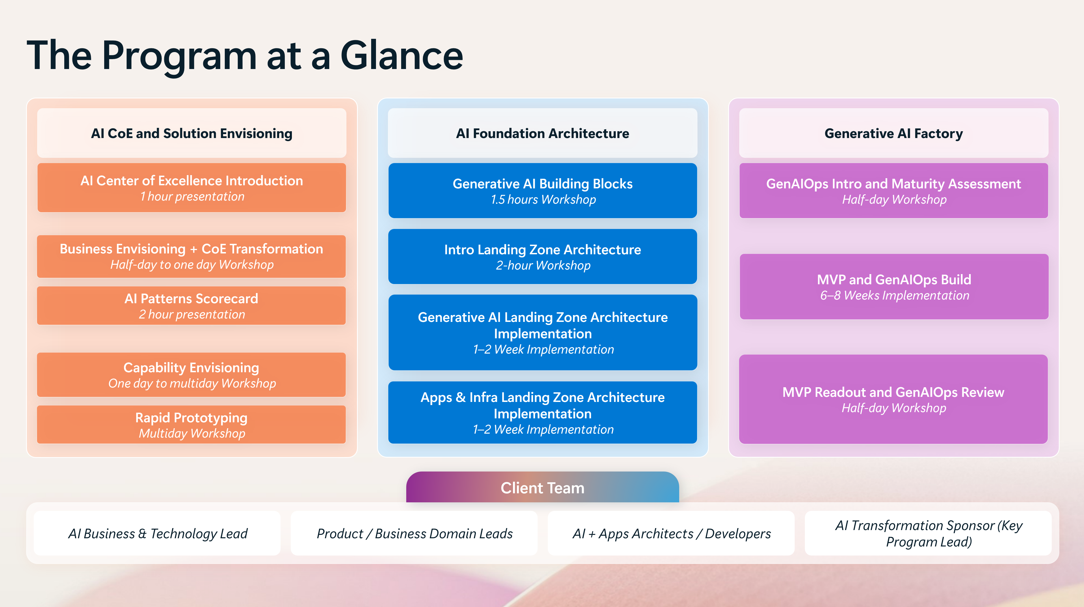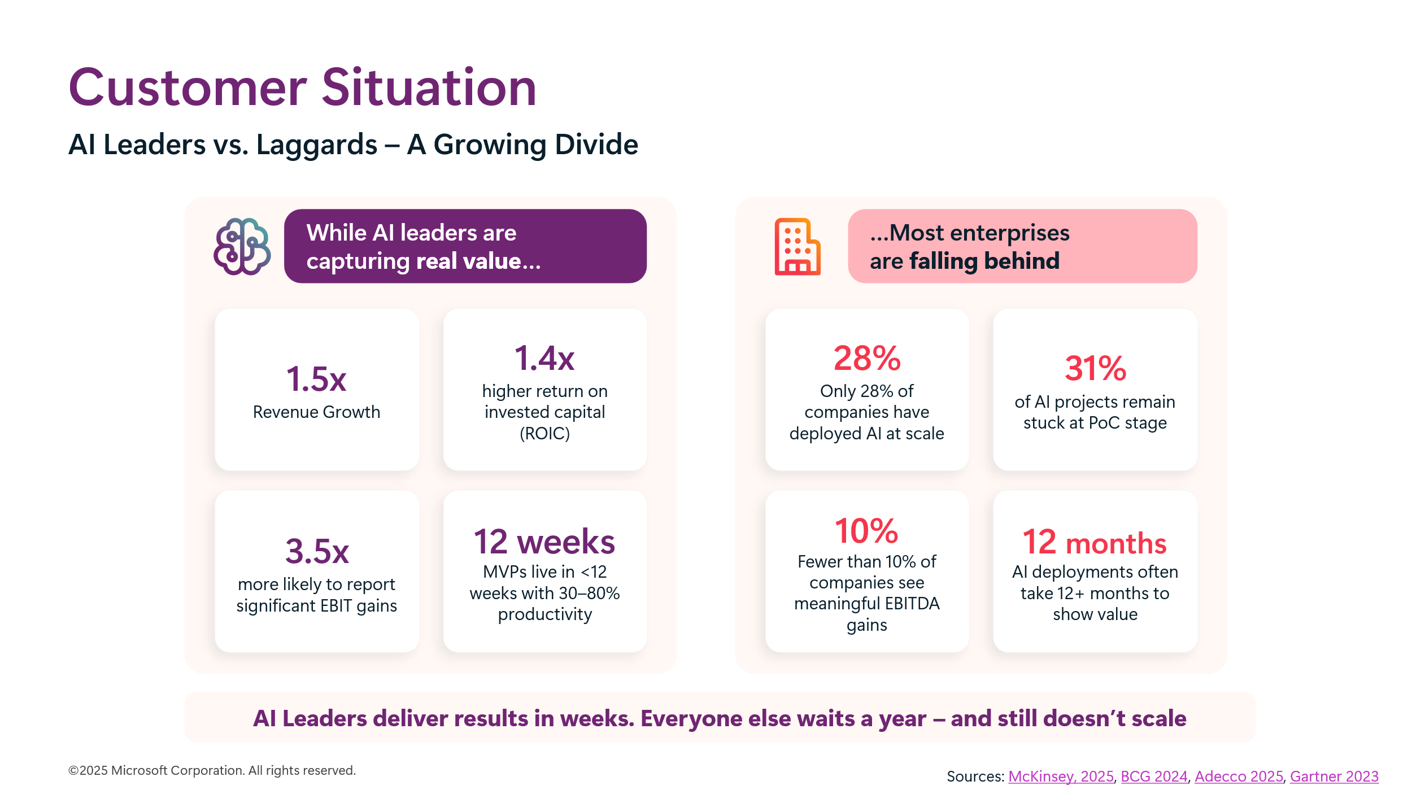

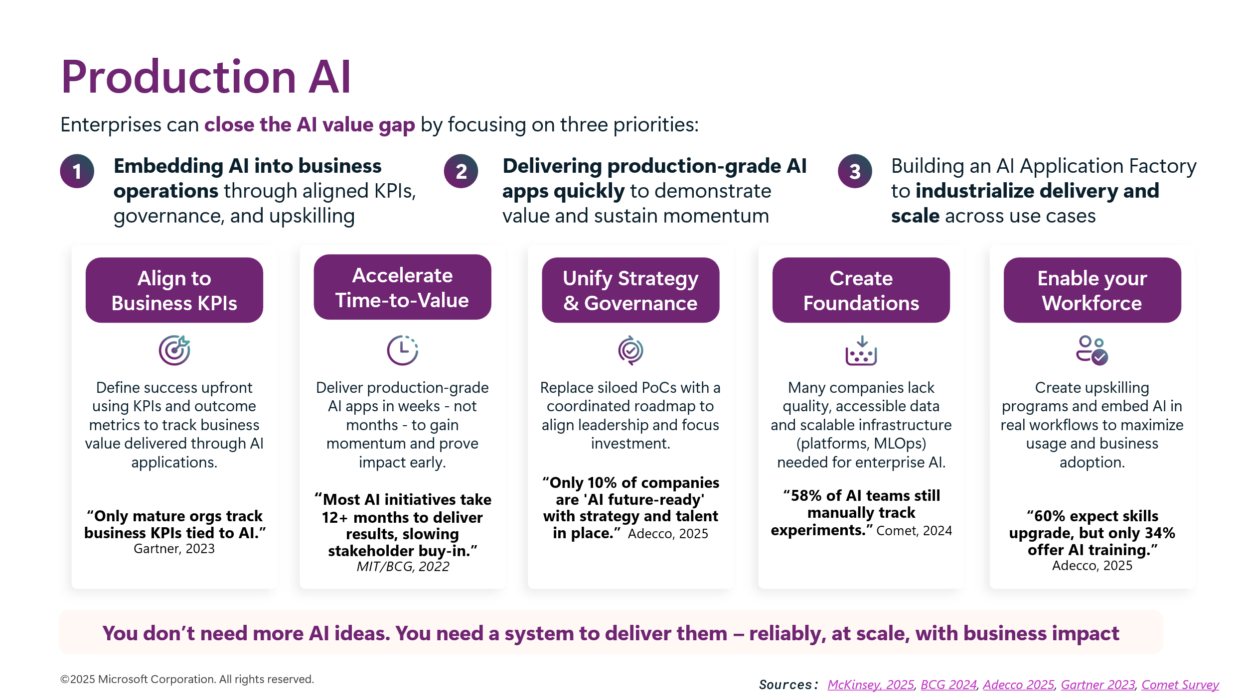


AI Foundation Architecture
By Contoso
<Contact Button> <Pricing Optional>

AI Transformation Offer: AI Foundation Architecture

Overview
The AI Foundation Architecture is a structured engagement designed to help organizations establish a secure, scalable, and production-ready foundation for AI workloads on Microsoft Azure.
As the core enabling phase of the AI Transformation Offer, AI Foundation Architecture focuses on building the technical bedrock required to move AI initiatives from experimentation to enterprise-scale production. This engagement addresses common challenges such as inconsistent environments, security and governance gaps, duplicated infrastructure effort, and delays caused by re-building foundations for every new AI initiative.
The AI Foundation Architecture enables organizations to implement standardized AI landing zones, platform guardrails, and operating patterns that support Generative AI, traditional AI, and agentic workloads—ensuring AI solutions can be delivered securely, reliably, and repeatedly across teams and business units.
This offer is designed for organizations that have AI ambition and use cases identified, but need a trusted, production-grade platform foundation to scale AI with confidence.

Key Benefits
- Establish a standardized AI foundation architecture aligned to enterprise security, compliance, and governance requirements
- Design and implement AI Landing Zones optimized for Generative AI and AI application workloads
- Reduce friction and rework by enabling repeatable, reusable platform patterns for AI delivery
- Accelerate time-to-production by providing ready-to-use AI environments for delivery teams
- Enable consistent identity, networking, security, and observability across AI workloads
- Create a scalable foundation that supports AI Factory and GenAIOps adoption downstream

High-Level Engagement Agenda
- Gernerative AI Building Blocks – 1.5 hour workshop
- Introduction to Landing Zone Architecture – 2-hour workshop
- Generative AI Landing Zone Architecture Implementation – Half-day workshop
- Apps & Infra Landing Zone Architecture Implementation – 1–2 weeks

Milestone Outcomes
- AI-ready Azure Landing Zone established or existing landing zones assessed and enhanced
- Standardized security, networking, identity, and governance controls implemented for AI workloads
- Platform foundation validated to support Generative AI Factory and GenAIOps execution

Prerequisites
- Access to Microsoft Azure subscriptions and target environments
- Alignment on enterprise security, networking, and governance standards
- Availability of platform, security, and AI stakeholders
- Identified AI or Generative AI initiatives that require production-ready infrastructure

Target Audience
- Enterprise and Cloud Architects
- AI Platform and Infrastructure Engineering Leaders
- Security, Identity, and Network Architects
- Data, AI, and Application Platform Teams
- Digital Transformation and Cloud Enablement Teams





Generative AI Factory
By Contoso
<Contact Button> <Pricing Optional>

AI Transformation Offer: Generative AI Factory

Overview
The Generative AI Factory is a structured engagement designed to help organizations move from fragmented Generative AI experimentation to repeatable, production-grade AI delivery at scale on Microsoft Azure.
As the final phase of the AI Transformation Offer, the Generative AI Factory focuses on industrializing AI delivery by establishing a factory-style operating model with GenAIOps at its core. This engagement helps organizations overcome common challenges such as stalled pilots, duplicated effort, and lack of production readiness by providing a clear path from idea to production.
This offer is designed for organizations that do not need more AI ideas, but need a system to deliver AI reliably, at scale, with measurable business impact.

Key Benefits
- Establish a repeatable Generative AI Factory operating model to industrialize AI delivery
- Assess GenAIOps maturity and define a roadmap for operational improvement
- Prioritize high-impact Generative AI use cases aligned to business outcomes
- Accelerate time-to-value by moving from PoC to production in weeks, not months
- Implement governed, secure, and responsible AI patterns on Microsoft Azure
- Enable scalable delivery of production-grade AI applications across multiple teams and use cases

High-Level Engagement Agenda
- GenAIOps Introduction & Maturity Assessment – Half-day workshop
- MVP + GenAIOps Build (Production Delivery) – 6–8 weeks
- MVP Readout & GenAIOps Review – Half-day workshop

Milestone Outcomes
- AI ready Azure Landing Zone established or existing landing zones assessed and enhanced
- Standardized security, networking, identity, and governance controls implemented for AI workloads
- Platform foundation validated to support Generative AI Factory and GenAIOps execution

Prerequisites
- Access to Microsoft Azure subscriptions and environments
- Development and production environments available
- DevOps / CI-CD workflows in place
- Availability of business, data, and technical stakeholders
- Identified Generative AI or AI use cases aligned to business goals

Target Audience
- Enterprise and Solution Architects
- AI, Data, and Platform Engineering Leaders
- DevOps, MLOps, and GenAIOps Teams
- Product and Application Engineering Leaders
- Digital Transformation and Innovation Teams




